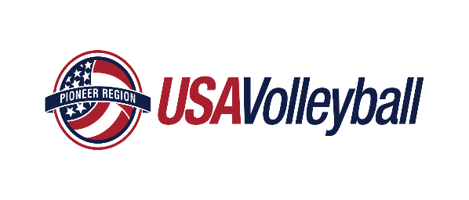
Pioneer Region JUNIOR CLUB PERSONNEL CODE OF ETHICS
It is the duty and obligation of USA Volleyball affiliated Junior Club Program administrators, directors, coaches and other club personnel to assure the following Code of Ethics is followed and adhered to by all individuals who have an active role in a USA Volleyball Junior Club Program in any Region of USA Volleyball.
In a continuing effort to promote safe, healthy and ethical communication, relationships and treatment of all USA Volleyball players and personnel.

1. All adult club personnel affiliated with a junior program must be a registered member with a Region of USA Volleyball and USA Volleyball.
2. All adult club personnel including coaches, chaperons, assistant coaches, trainers, etc. affiliated with a junior program intending to participate in USA Volleyball must have an approved and current background screen and Safe Sport certification on file as per USA Volleyball policy. It is intended that the term 'all adult club personnel' be all inclusive and not limited to only those categories identified herein.
3. A head coach or assistant coach affiliated with a junior program must also: be IMPACT certified according to USA Volleyball and Region policies. Head coach must be an adult (see region policy)
4. If allowed by Region rules, an assistant coach who has not yet met the age of majority in the state of residence must be supervised by a head coach recognized by the Region and must meet all applicable Region and USA Volleyball requirements. Individuals who are registered as junior players and also have an interest in coaching should contact the region regarding coaching eligibility.
5. Responsibilities:
A. Head coach or other equally qualified club personnel must be present at all practices and competitions. A head coach, adult club representative personnel or registered chaperone must be present during team-supervised travel. This individual shall be responsible for the moral, legal, and ethical well-being for each participant during team/club activities.
B. Coaches shall understand the unique power of a coach-athlete relationship. Coaches and all other club personnel shall not exploit athletes and shall avoid any relationships which could compromise the integrity of the learning and participation process, impair their professional judgment and/or take advantage of a situation for their own personal gain or gratification.
C. All club personnel must understand that all forms of sexual abuse, assault or harassment of a current or former athlete are unethical and illegal even when an athlete invites or consents to such behavior or involvement. Club personnel shall not engage in sexual/romantic relationships with current athletes or other participants over whom there is/was authority. See B above.
D. All club personnel shall insure that all individuals have met all Regional Volleyball Association and USA Volleyball membership requirements prior to participation in any club, team and/or Region/National USA Volleyball activity.
E. All club personnel must inform the players and their parent(s)/guardian(s) about any Region and/or USA Volleyball transfer policy. This policy may restrict or prohibit a participant from transferring to another club or team if specified criteria have been met. Likewise, all club personnel must inform the players and their parent(s)/guardian(s) of any rules or policies regarding coaching transfers during a particular season.
F. All club personnel shall abide by and inform the players and their parent(s)/guardian(s) of applicable regional recruiting policies.
G. All club personnel may not participate in, require another individual to participate in, or condone any act considered to be illegal under federal, state or local laws and/or ordinances.
H. All club personnel shall strive to educate their athletes and personnel to respect, honor and adhere to the rules of the facility being used during practices, tournaments, or events. In this regard, the rules of the facility shall have priority over the rules of the Regional Volleyball Association.
I. All club personnel shall ensure that all activities are suitable for the age, experience, and ability of their athletes.
J. All club personnel shall seek professional medical advice when making decisions regarding an injured athlete's ability to continue training or playing.
K. All club personnel shall, while serving in a professional capacity, avoid any drug, tobacco, or alcohol use while in the presence of athletes.
L. All club personnel shall not supply or condone the use of drugs, alcohol, tobacco, fireworks, ammunition, firearms, knives or any item or material that can be used as a weapon, to any of the participants or athletes and shall report any athlete using or in the possession of the same.
M. All club personnel shall not allow, encourage, condone, or require any behavior that threatens an athlete's amateur status or Regional, USA Volleyball, school and/or collegiate eligibility.
N. All club personnel shall maintain all relationships with other club personnel on a professional and confidential basis.
O. All club personnel must be positive role models. This includes being courteous, respectful and polite to players, parents, other coaches, club directors, event personnel, and officials.
P. All club personnel will not engage in any physical, verbal or emotional harassment, abusive words or actions, or coercion of current and/or former athletes.
Q. All club personnel will immediately report any suspected case of illegal activity, abuse, assault, harassment, or ethical violations of this club personnel code of ethics to the appropriate authorities, including Regional Volleyball Administrators.
Any violation of this Code may result in sanction being issued against the club representative, the individual(s) and the club/team involved. These sanctions may extend to the loss of eligibility of the club representative, the individual(s), the entire club and the team involved.

